All Weather Portfolio

Period [2013 to 2019 1st half]

etf_tickers = ['IVV', 'TLT', 'IEF', 'GLD', 'DBC']

mc_budget = [0.30, 0.40, 0.15, 0.08, 0.07]

1. Historical

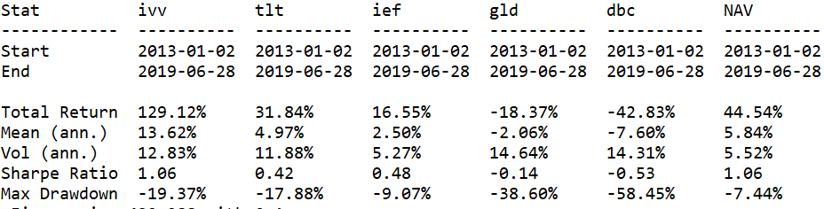

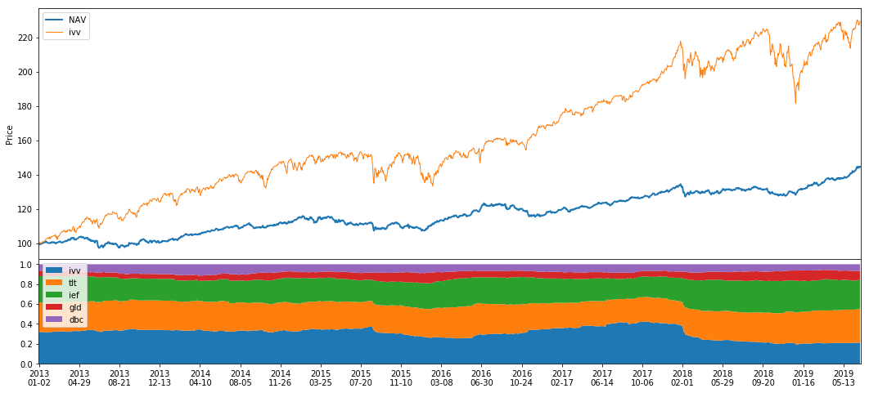

1. GARCH

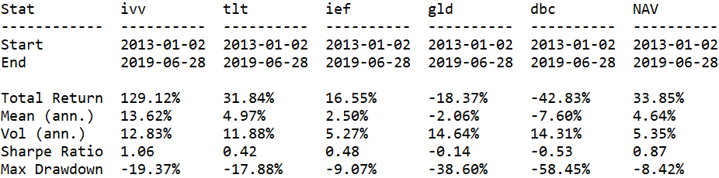

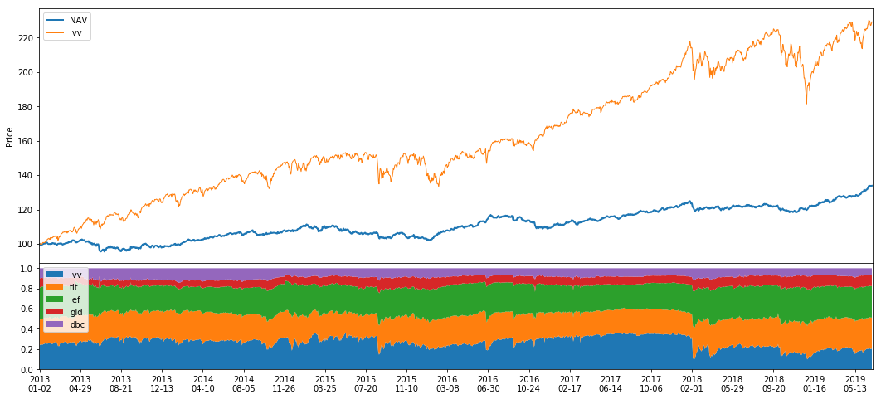

1. Future (for reference)

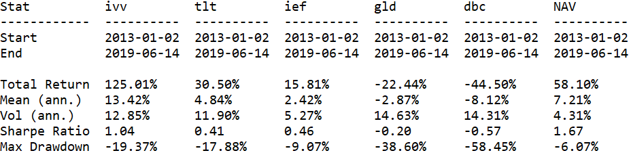

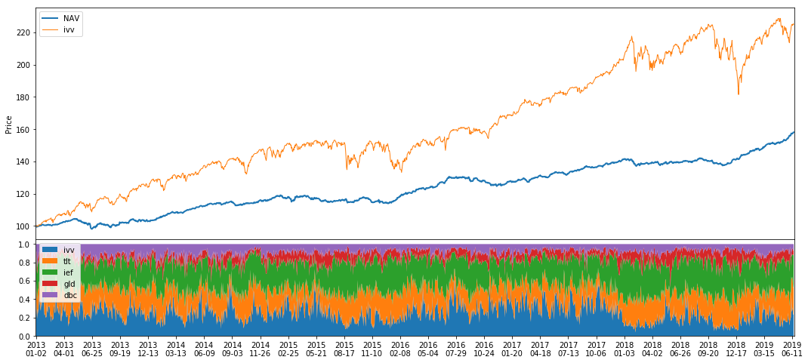

1. LSTM (4 features)

4.1 var (average = 5, future days=30)

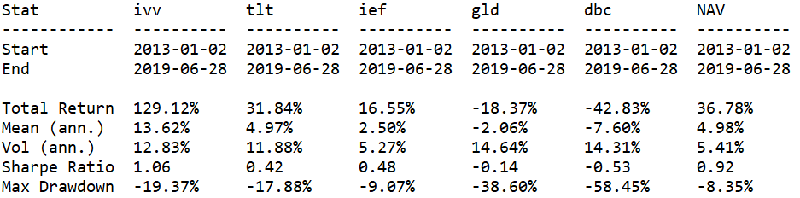

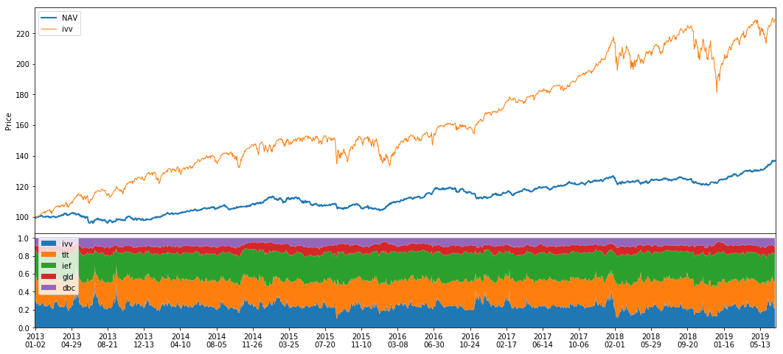

var (average = 10, future days=60)

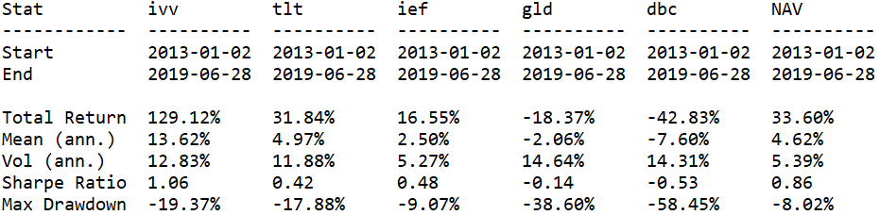

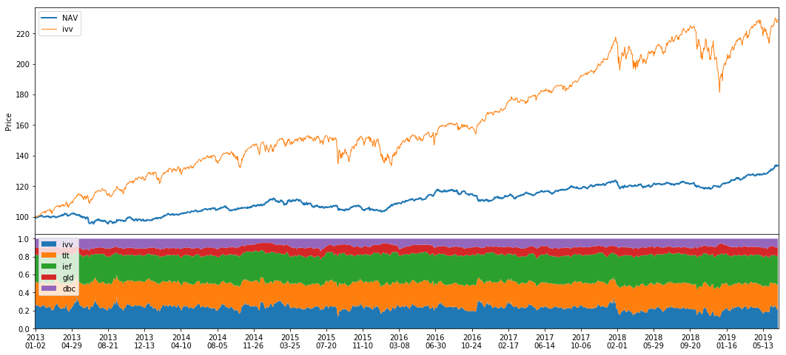

* 1. var (no average)

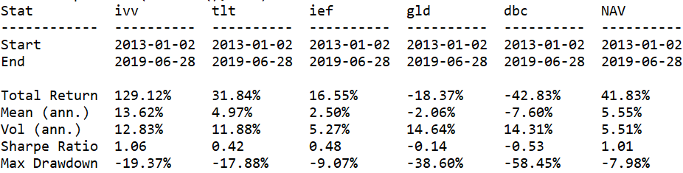

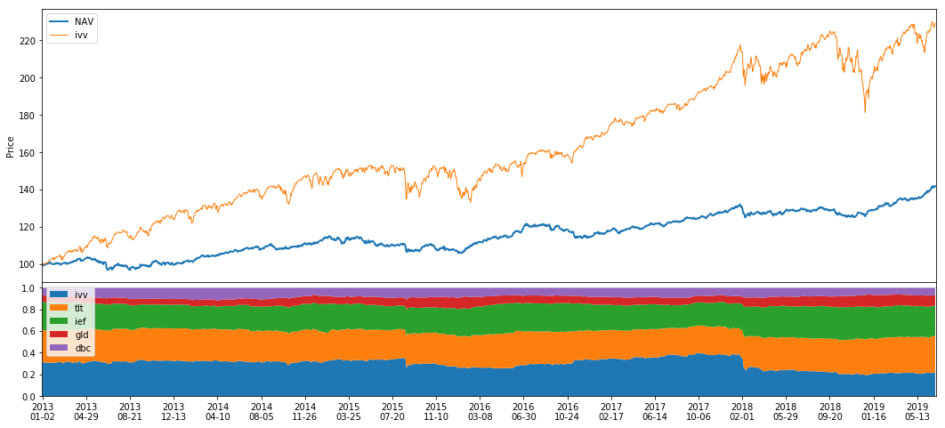

var (no average) 5 features + historical variance

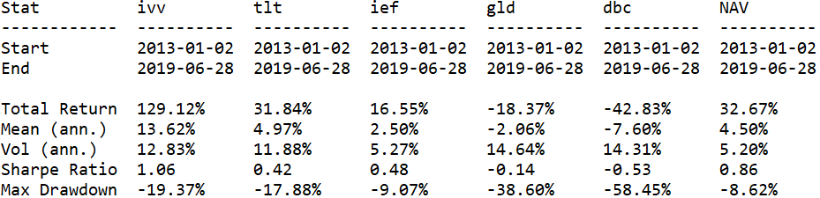

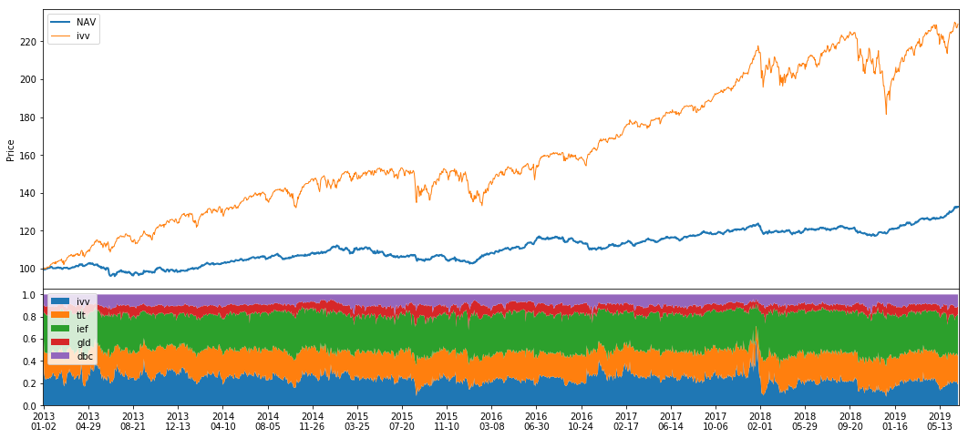

* 1. var negative

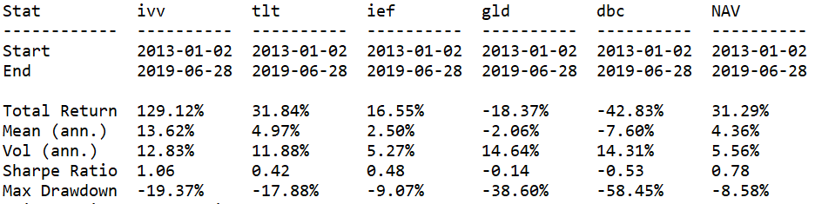

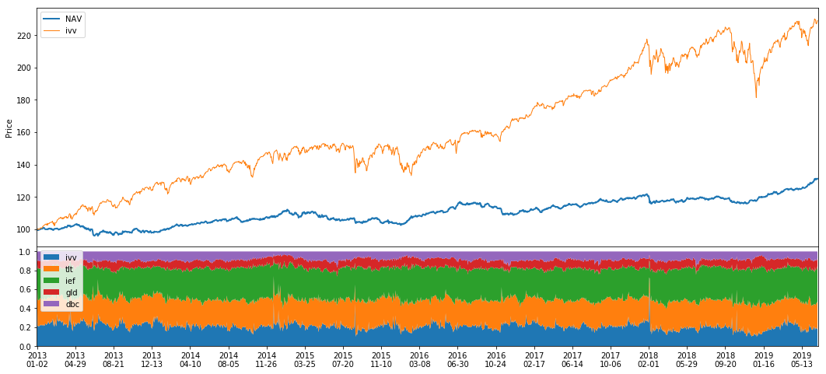

4.4 var with slope and diff

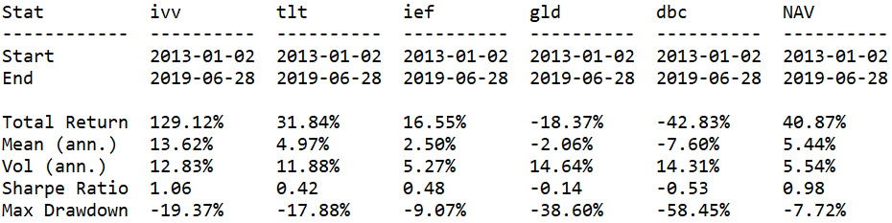

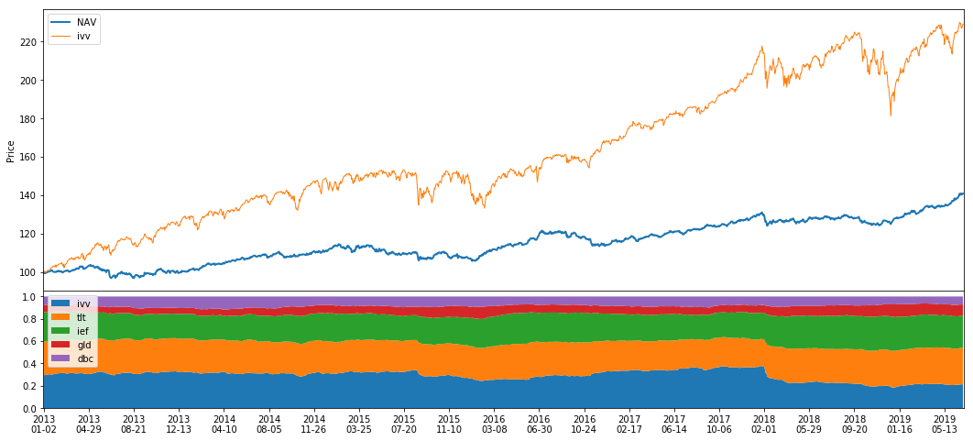

4.5 var with slope, diff and historical var

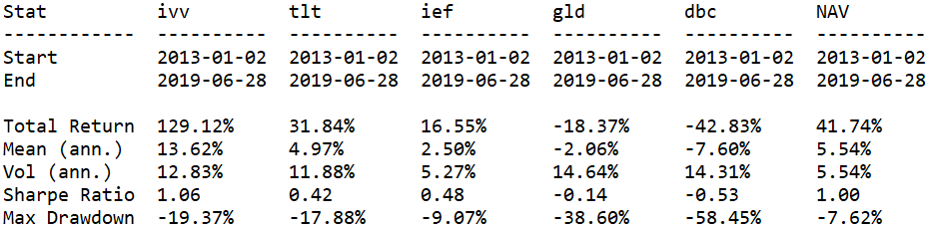

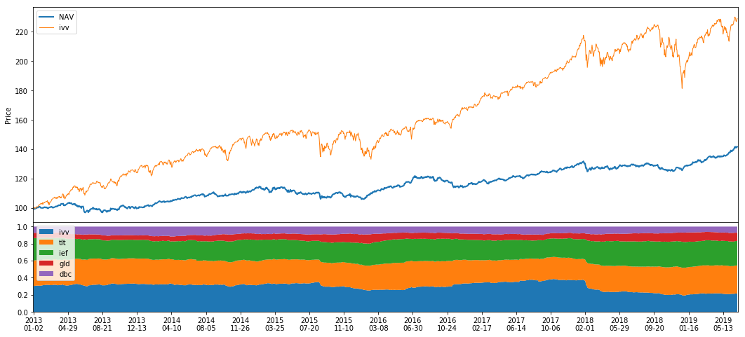

1. forecast covariance

